Assessing the Geographical Reproducibility of Large-scale Granulate-based 3D Printing of Recycled Polyethylene Terephthalate Plastic Bottles
Catalina Suescun Gonzalez^{1,2}, Aditi Basdeo^{3,4}, Alessia Romani⁵, Fabio A. Cruz Sanchez¹, Cécile Nouvel², Hakim Boudaoud¹, Joshua M. Pearce^{4,5},
¹Université de Lorraine, ERPI, F-54000, Nancy, France.
²Université de Lorraine, CNRS, LRGP, F-54000 Nancy, France
³Department of Chemical and Biochemical Engineering, Western University, London, ON Canada
⁴Ivey Business School, Western University, London, ON Canada
⁵Department of Electrical & Computer Engineering, Western University, London, ON Canada
Abstract
Distributed recycling for additive manufacturing (DRAM) offers a pathway to reduce manufacturing costs by transforming plastic waste into 3D printing feedstock. This study evaluates the geographical reproducibility of a distributed recycling and open-source manufacturing approach originally developed in France. The approach enables the local transformation of post-consumer plastic bottles into new products through large-scale direct screw-feeding additive manufacturing, when implemented in a North American context. The results show that the operational difficulty index (ODI) increased from 1.6 to 2.2, highlighting challenges related to material collection, shredding, and printing. Different recycled feedstocks were assessed in terms of particle characteristics, extrusion behavior, and printed-part quality. Process parameter optimization improved material flow consistency and printability despite the irregular geometry of recycled particles. Mechanical testing demonstrated that recycled blend materials compatibilized with 5 wt % SEBS-G1652 achieved tensile strengths of 19 ± 3.5 MPa, demonstrating the mechanical performance attainable with the compatibilized recycled material.. Finally, the potential use of recycled feedstock was demonstrated by 3D printing large-scale parts as a case study of real-world applications.
Keywords: distributed recycling for additive manufacturing (DRAM), closed-loop recycling, upcycling, polyethylene terephthalate (PET), fused granular fabrication (FGF), fused particle fabrication (FPF), material extrusion (MEX).
List of Abbreviations
Acronym  AdI  AM  CAD  CS | Definition  Adaptability Index  Additive Manufacturing  Computer-aided design  Critical stage
DRAM  FDM | Distributed recycling and additive manufacturing  Fused deposition modeling
FFF  FGF  FPF | Fused filament fabrication  Fused granular fabrication  Fused particle fabrication
HDPE | High density polyethylene
KPIs | Key performance indicators
MEX  ODI  OSF  PET  PLA  PP  SEBS  SEBS-g-MA  SLM  STL | Material Extrusion  Operational difficulty index  Open science framework  Polyethylene terephthalate  Polylactic acid  Polypropylene  Poly(styrene-b-(ethylene-co-butylene)-b-styrene)  Maleic anhydride-grafted SEBS  Selective laser melting  Stereolithography

Introduction
In recent years, the alarming increase in plastic that ends up in the oceans and landfills (approximately 60% of the plastic produced) (Suhaimi et al., 2022) has driven the need for re-evaluation and reconsideration of waste management alternatives. Recycling has become a preferred option to address the growing volume of plastic waste (Mwanza and Mbohwa, 2017). Traditionally, plastic waste has been recycled in centralized facilities. Although this approach has been effective for certain plastics such as polyethylene terephthalate (PET), high-density polyethylene (HDPE), and polypropylene (PP), exhibiting ~80 %, ~84 %, and ~71 % of recycling rates, respectively (Antonopoulos et al., 2021), challenges related to collection and transportation persist (Kreiger et al., 2014). This fact highlights the necessity of adopting strategies incorporating local recycling facilities to create a more sustainable and long-lasting recycling ecosystem (Kassab et al., 2023). In this context, distributing recycling has emerged as an additional approach for waste management, where recycling facilities are located close to the waste generation point to reduce the logistical and transportation challenges, hence increasing the efficiency of the waste treatment. Distributed recycling has been demonstrated to be more effective than traditional centralized methods, particularly in reducing environmental impacts. For instance, in the case of recycling HDPE for the production of 3D printing filament, it significantly lowers embodied energy (Kreiger et al., 2014). It also reduces CO₂ emissions from transportation (Santander et al., 2020), land use (Kerdlap et al., 2022), water and fossil resource depletion, and the potential of both freshwater and marine eutrophication(Caceres-Mendoza et al., 2023). Furthermore, distributed recycling contributes to developing a more adaptable and resilient system to minimize environmental impacts (Kassab et al., 2023).
Similarly, additive manufacturing (AM), or 3D printing, has experienced exponential growth as an alternative to traditional manufacturing methods, fostering distributed manufacturing. The set of technologies in the AM spectrum enables the fabrication of customized components with complex geometries applicable across various industries Additive manufacturing (AM) becomes the successful commercial technology because of the interdisciplinary applications of this technology in different sectors(Taufik and Jain, 2024). The process involves adding material layer by layer, following different procedures according to the specific technology categories defined in the ISO/ASM 52920:2023 standard, i.e., VAT photopolymerization, material jetting, binder jetting, powder bed fusion, sheet lamination, direct energy deposition, and material extrusion (MEX) (ASTM International, 2021). Studies indicate that selective laser melting (SLM) and the patent-expired but trademarked fused deposition modeling (FDM) or open fused filament fabrication (FFF), belonging, respectively, to the powder bed fusion and MEX categories, are the most frequently employed and studied techniques. Furthermore, significant potential and emerging trends include the employment of metallic (Das et al., 2016), ceramic (Esposito Corcione et al., 2019; Mohd Pu’ad et al., 2020), composite (Giani et al., 2022; Park et al., 2023; Singh et al., 2019), and advanced materials (“Progress in 3D Printing of Carbon Materials for Energy‐Related Applications - Fu - 2017 - Advanced Materials - Wiley Online Library,” n.d.; Truby and Lewis, 2016), along with medical applications, such as bioprinting (Ahangar et al., 2019), tissue engineering (Babilotte et al., 2021; Mohseni et al., 2018), pharmaceuticals (Goyanes, 2015; Goyanes et al., 2014; Serris et al., 2020), and design specifically tailored for AM., i.e., construction (Bos et al., 2016; Tay et al., 2019). Despite these advancements, the primary challenge remains the absence of standardized regulations and certified procedures (Jemghili et al., 2021), together with the cost of materials and 3D printers. Among these AM techniques, however, MEX is one of the most widespread and cost-effective, primarily used to shape thermoplastic polymers, i.e., through FFF (Askari et al., 2020).
In the FFF process, a thermoplastic polymer is heated and extruded through a nozzle, layer by layer, to build the desired object (Mohd Pu’ad et al., 2020). This method is favored due to its lower cost, material flexibility, and reduced production expenses (Askari et al., 2020). The integration of polymer recycling with additive manufacturing has emerged as an innovative approach for MEX, especially FFF. It enables direct 3D printing of recycled plastics through a decentralized recycling process known as distributed recycling for additive manufacturing (DRAM). This model aims to mitigate the environmental crisis caused by plastic waste accumulation in landfills in terms of transportation [6], [28], water depletion [8], material reprocessing [29], and enhancing the circularity and revalorization of plastic waste from post-consumer goods (Kassab et al., 2023). DRAM makes use of the MEX technologies to open the technical path for discarded plastics such as PET (Little et al., 2020; Romani and Levi, 2024), PP (Justino Netto et al., 2021), and PLA (Alexandre et al., 2020; Romani et al., 2024b), to be recycled in new applications, presenting new opportunities for waste management, particularly through FFF. Within MEX techniques, fused granular fabrication (FGF, or fused particle fabrication, FPF) also offers an additional strategy that enables the direct use of recycled granulated materials for new product applications, such as plastic pellets or flakes (Justino Netto et al., 2021; Romani and Levi, 2024; Vicente et al., 2023). This method has demonstrated cost reductions and expanded the range of recycled materials by eliminating the need to convert them into 3D printing filaments (Little et al., 2020; Romani et al., 2024b; Woern et al., 2018) or allowing the direct mixing of blends and polymer-based composites (Romani et al., 2023; Suescun Gonzalez et al., 2024), (Alexandre et al., 2020). Using FGF processes for DRAM can reduce the reprocessing steps and the thermomechanical degradation of the extrudate (Romani et al., 2024b), enabling faster and more cost-effective 3D printing processes (Curmi and Rochman, 2022). In parallel, the development of open-source additive manufacturing has contributed to the democratization and accessibility of AM technologies by enabling the sharing, modification, and adaptation of hardware, software, and technical knowledge to specific local needs (Fidan et al., 2023).
The DRAM approach using open-source hardware has shown great potential for revalorizing post-consumer plastic waste through FGF (Nguyen et al., 2024; Oberloier et al., 2022; Romani et al., 2024a), achieving a reduction in environmental impact of up to 82.1% compared to FFF (Bilal et al., 2024). Additionally, it has shown potential for direct one-step blending of PET-HDPE water bottles in the specific context of France (Suescun Gonzalez et al., 2024). This methodology may also be scalable in different contexts, providing valuable insights into its reproducibility, ensuring that DRAM could be a potential plastic waste recycling strategy to be deployed in specific territories and contexts. Nevertheless, the reproducibility of the DRAM model has not been adequately assessed, lacking reproducibility assessment of comparable approaches, waste source, and equipment when used in different geographical contexts.
This work extends a previous conference study focused on the reproducibility of the DRAM model and methodology for processing and printing multi-material post-consumer pastic wastein a different geographical context (Gonzalez et al., 2026). In detail, the work replicates the DRAM model applied in France to post-consumer plastic waste, i.e., using recycled water bottles, in a North American context to assess how differences in local conditions, available equipment, and processing resources affect its implementation.. This model includes the collection, transformation of plastic waste, and direct screw-feeding 3D printing of the material using a large-scale FGF 3D printer. At first, the reproducibility of the approach is evaluated through a proposed methodology. During its implementation, some challenges were encountered in the 3D printing process mainly due to the inconsistency of the extrudate flow. To address this issue, this study also explores the impact of different particle shapes on flow consistency and 3D print quality, i.e., flakes, shredded particles, and pellets. The mechanical properties and the fabrication of large-scale parts are evaluated to demonstrate the potential use of the processed post-consumer plastic waste as a feedstock for FGF 3D printing and its applicability to real-world manufacturing scenarios..
Beyond the geographical replication itself, the novelty of this work lies in investigating decentralized plastic valorization through direct 3D printing and open-source technologies as an accessible alternative for contexts where the infrastructure and financial resources required for centralized recycling may be limited. In this framework, local conditions become particularly relevant, as differences in waste availability, collection practices, material contamination, equipment accessibility, and operational capacity may directly affect the implementation of the process.

Materials and Methods

Materials
In this study, post-consumer Cristaline water bottles coming from Nancy, France, and Kirkland and Pure Life collected from communities near Western University in London, Ontario, were used. The composition is approximately 90 wt% PET (body) and 10 wt%. HDPE (cap). The transformation of the bottles into feedstock followed a procedure from a previous study (Suescun Gonzalez et al., 2024).
Virgin polylactic acid (PLA) pellets were provided by NatureWorks (Savage, MN, USA). The linear styrene-ethylene/butylene-styrene block copolymer (SEBS) Kraton G1652, including about 30 wt% of polystyrene, was generously donated by Kraton Polymers in Almere, Netherlands. Maleated SEBS cirKular+ C1010 was donated by Univar Solutions (France).

2.2 Fused Granular Fabrication (FGF)
A modified 3-heat-zone (T1: nozzle temperature; T2: temperature at the middle of the barrel; and T3: temperature near the feeding zone) large-format open-source 3D printer (Gigabot XLT re:3D, Houston, TX, USA) was used to print the collected material. This 3D printer is a single-screw extrusion 3D printer with a nozzle size of 1.75 mm, capable of directly 3D printing particle-based feedstocks, such as pellets, flakes, or granules. To improve machine performance and the user experience, and enable the comparison with the 3D printer used in France, the updates presented in a previous work were implemented (Gonzalez et al., 2026).
All CAD models developed to upgrade the FGF printerwere redesigned using Onshape CAD v1.180 (PTC Inc., Boston, MA, US). The STL files were sliced using PrusaSlicer v2.6.1 and fabricated with an open-source FFF Prusa i3 MK3s 3D printer with a 0.4 mm nozzle (Prusa Research, Prague, Czech Republic) (Prusa 3D, n.d.). The CAD models, STL files, and 3D printing profiles are available in the OSF repository(Gonzalez et al., 2024).
  - Reproducibility assessment
To evaluate the reproducibility of the DRAM model in the context of large-scale 3D printing, particularly for the revalorization of recycled water bottles, a proposed methodology is outlined in Fig. 1. The steps implemented from this methodology were 1, 2, 5, and 6. Steps 3 and 4 were not executed, as initial considerations regarding material characterization and 3D printing parameters were analyzed by previous studies (Suescun Gonzalez et al., 2024) with the exception of Stage A of Step 3 (“Particle Size”), which was conducted as part of the present study.
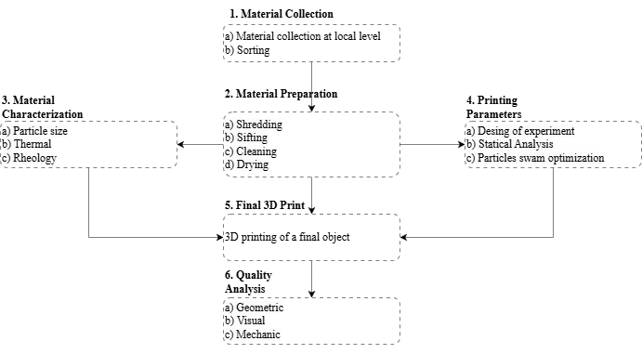
Figure 1. 3D printing multi-material post-consumer waste methodology
Additionally, three key performance indicators (KPIs) were defined to assess the performance of DRAM in different regional contexts. This KPI’s were calculated based on qualitative difficulty levels assigned to each process stage. The levels scores were assigned by the researcher who participated directly in the experimental work at both geographical locations, thereby ensuring a common evaluator across the two scenarios. The difficulty levels were classified as low (green = 1), intermediate (yellow = 2), and high (red = 3), based on criteria such as complexity, time consumed, required coordination, and availability of resources and technology (Gonzalez et al., 2026).
The three KPIs, operational difficulty index (ODI), critical stage (CS), and adaptability index (AdI), were developed based on principles from qualitative multi-criteria decision-making approaches (Ennaceur et al., 2013), specifically the best worst method (Rezaei, 2016), as well as bottleneck analysis (Small, 2015).
- ODI quantifies the average difficulty across all stages and is calculated according to Equation 1:
$ODI=\frac{\left(ΣDi\right)}{n}$(1)
Where D_{i} is the difficulty score for stage i, and n is the total number of evaluated stages.
- CS identifies the number of stages categorized as high difficulty (red level), which may represent potential bottlenecks in the system. It calculates as shown in Equation 2:
$CS=Σ δ(Di = 3)$ (2)
Where 𝛿(D_{i}=3) is an indicator function that returns 1 if the stage difficulty equals 3 and 0 otherwise.
- AdI reflects the percentage of stages rated as low difficulty, indicating the extent to which the DRAM can be readily applied. It is calculated by Equation 3 as:
$$AdI=\left[\frac{Σ δ\left(Di = 1\right)}{n}\right]× 100 ( SEQ Equation \backslash * ARABIC 3)$$

Particle characterizationand flow assessment
Particle characterization (particle size and geometry) is essential to ensure processability in FGF (Romani et al., 2024b; Woern et al., 2018). Given the heterogeneous nature of shredded bottle outcomes, the objective was to assess shape and flow consistency based on feedstock granulometry. Four particle types were evaluated: 1) commercial pellets (virgin PLA) as a benchmark, 2) flakes (directly shredded from water bottles), 3) shredder particles from previous 3D-printed parts, and 4) laboratory-made pellets (pelletized).
The flakes particles were prepared following procedures reported in previous studies (Suescun Gonzalez et al., 2024). The shredded materials were obtained from previous 3D-printed parts using a Filabot Reclaimer machine (USA)(“Reclaimer,” n.d.). Then, manually sifted using a 3D-printed sieve with a 3 mm grid to ensure uniformity in particle dimension, which is critical for consistent extrusion performance, as shown in previous studies (Little et al., 2020; Suescun Gonzalez et al., 2024). The sifted material was then 3D printed.
For the elaboration of laboratory-made pellets, the bottles were mechanically shredded with an open-source machine developed based from Fanshawe University (“Academy - Precious Plastic Community,” n.d.). The materials were manually sifted with a 3 mm mesh, and no cleaning processes were performed. Then, sifted material was extruded through the GigaboX system at 255°C to produce a first filament feedstock. Then, this filament served as the feedstock for a pelletizing process developed in previous works (Ravindran et al., 2019), resulting in the production of 500 grams of pellets. Additionally, all the particles were dried overnight at a controlled temperature of 60°C using a VWR scientific oven (Avantor, USA) (“Ovens | VWR,” n.d.).
The particle granulometry characterization of all the different shape types of feedstocks obtained from one batch (n=1) was conducted using open-source ImageJ software (Image J, n.d.).
Subsequently, the flow consistency for granulate feedstocks was assessed by investigating the impact of extrusion multiplier (EM), a term frequently used in 3D printing but relatively underexplored in the literature.The extrusion multiplier is a 3D printing parameter in charge of controlling the amount of material flowing from the 3D printed nozzle during layer deposition (Ghorbani et al., 2022). At this stage, the specific objective was to explore the effects of varying EMs during 3D printing of the different particles.
Flow consistency was visually and dimensionally assessed using two different geometries. First, asnake-shaped geometry (n=1), shown in Fig. A1.a (Appendix A), with overall dimension of 2 × 594 × 2 mm and a line width of 2 mm, was 3D printed. For each EM value, the printed geometry was measured at 13 different points using a caliper to assess dimensional consistency.Second, simple square specimens with dimensions of50 × 50 × 5 mm, as presented in Fig. A1.b (Appendix A), were printed. For the snake-shaped geometry, the EM was adjusted directly in the G-code during printing, whereas for the square-shaped geometries, the EM was modified through the slicer settingsThe values variated s from experimental values from 100 to 300
The aim is to compare the optimal percentage of EM need to 3D print each type of geometry and ascertain whether adjusting this factor could resolve under extrusion issues. All the designs and parameters used for this study are available on the Open Science Framework (OSF)(Gonzalez et al., 2024). Table 1 resumes the main 3D printing parameters used to assess the flow consistency and EMs with the different granulate feedstocks.
Table 1. Main 3D printing parameters (PET/HDPE and PLA feedstocks) for (a) the samples for the assessment of the flow consistency and EMs, (b) the tensile test specimens, and (c) the case study (crown molding).
Parameters | Units | Values
Parameters | Units | Samples for flow consistency and EMs, tensile specimens |  | Case study (crown molding)
 |  | PET/HDPE | PLA | PET/HDPE | PLA
T1 | °C | 264 | 170 | 264 | 170
T2 | °C | 232 | 170 | 232 | 170
T3 | °C | 220 | 162 | 220 | 162
Tbed | °C | 84 | 60 | 100 | 100
Line width | mm | 1.97 |  | 1.97
Speed | mm/s | 20 |  | 20
Top/Bottom layers | // | 2 |  | //
Infill percentage | % | 100 |  | 0
Infill raster angle | ° | 45 |  | //
First Layer height | mm | 0.2 |  | 0.2
Layer height | mm | 0.5 |  | 0.8
EM | // | Variable 100-300 |  | 220
Cooling | // | Off |  | Off
T Room | °C | 22 |  | 22
Vase mode | // | Off |  | On
Nozzle diameter | mm | 1.75 |  | 1.75

2.5 Application case study
To evaluate the printability of the different particle types explained in section 2.4, a functional object was 3D printed, i.e., a crown molding for interior wall decoration, commercial virgin PLA pellets, used as a benchmark, shredded recycled water bottle flakes, and pelletized were used. The most effective compatibilizer identified in the mechanical tensile tests was utilized for 3D printing. The 3D model selected for 3D printing was obtained from Thingiverse (Thingiverse.com, n.d.) and was scaled and sliced using PrusaSlicer V2.6.0 (Prusa Research, Prague, Czech Republic). The 3D printing parameters are resumed in Table 1, and the 3D printing profiles are available on the Open Science Framework (OSF)(Gonzalez et al., 2024).

Results and discussion

Reproducibility assessment
The reproducibility of the process was assessed through the validation defined in the methodology presented in Fig. 1, which considers: (1) material collection; (2) material preparation; (3) 3D printing; (4) 3D printing quality analysis.

3.1.1 Material collection
The objective of material collection is to recover plastic waste to mitigate its environmental impact. This stage aims to identify the appropriate type and collection method for post-consumer waste. In the literature, Balwada et al. (2021) (Balwada et al., 2021) assessed five worldwide techniques for waste collection, namely: vehicular collection, curbside collection, drop-off recycling, buy-back center, and deposit/refund method presented in (Table B1, Appendix B).
In the North American context, material collection was conducted manually through a door-to-door approach in communities near Western University in London, Ontario. Three households participated on a weekly basis for approximately three months, donating their materials. As a result, around 522 Kirkland and Pure Life water bottles were collected. Although this approach proved to be effective at the research level, a more efficient method is needed to ensure the collection of larger volumes of materials, greater community engagement, and improved transportation efficiency.

3.1.2 Material preparation
After collecting the material, it is necessary to transform post-consumer waste into 3D printing feedstock. The literature outlines four preparation steps: identification/separation, sorting, size reduction, and cleaning. In the proposed methodology (Fig. 1), the identification/separation process was omitted, and sifting and drying were added according to the specific collection method and manufacturing technology selected for the assessment, which means a door-to-door approach for specific post-consumer goods and FGF of mechanically recycled plastics.

Shredding
This step aims to reduce the size and transform the collected material into flakes or particles suitable for the FGF 3D printing process. Different types of shredders can be used, ranging from industrial (“Create 3D Print Filament - Filament Maker and Plastic Shredder | 3devo,” n.d.; “Trituradoras de mandíbula: alta calidad y fiabilidad de RETSCH,” n.d.), semi-industrial open-source (“Academy - Precious Plastic Community,” n.d.; Plastic odyssey, n.d.), (“Reclaimer,” n.d.), laboratory-made (Okunola et al., 2019) apparatuses to domestic appliances, such as blenders and food processors (Braanker, n.d.).
In this study, three different shredders were used. Flakes sourced from France were processed using a cutting mill (Retsch MS300) (“Trituradoras de mandíbula: alta calidad y fiabilidad de RETSCH,” n.d.). In North America, particles from previously 3D-printed parts were shredded with a Filabot Reclaimer machine (USA) (“Reclaimer,” n.d.). Finally, plastic bottles collected from communities near Western University in London were intended to be shredded using the filabot. However, due to difficulties encountered, an open-source machine developed based on the design from Fanshawe University (“Academy - Precious Plastic Community,” n.d.) was employed. The major requirement of a shredder for this work is to guarantee the processing of plastic materials without significantly increasing their temperature, reduce the energy associated with melting, avoid thermal degradation, which can negatively affect the mechanical properties, and minimize the time required for this task.

Sifting
The goal of this step is to separate particles into groups of different sizes and consistent granulometry to select the most suitable ones for the machine's capacity, feeding, and extrusion system. The sifting process is designed to mitigate the risk of machine blockage during 3D printing, which may occur due to the presence of particles of inappropriate size. A 3D-printed sieve incorporating a 3 mm grid was fabricated and utilized, as this configuration was determined to be optimal for 3D printing the flakes (Suescun Gonzalez et al., 2024).

Cleaning
Post-consumer waste is often contaminated with various impurities, making the recycling process difficult. The primary objective of cleaning is to eliminate these impurities to ensure a high-quality feedstock material without impurities. While the literature does not specify particular washing methods, manual washing appears to be commonly employed (Razavi et al., 2011; Vaucher et al., 2022; Zander et al., 2019, 2018). Researchers in Nigeria (Okunola et al., 2019) developed a shredder-washing machine specifically for processing PET bottles, capable of shredding and cleaning 50-75 kg of plastic bottle waste per hour. Additionally, initiatives such as “plastic odyssey” develop low-cost, open-source technologies for plastic treatment (Plastic odyssey, n.d.). Both machines use centrifugal principles similar to a normal washing machine for clothes, making an interesting approach for local waste washing. In industrial settings, mechanical recycling processes often utilize friction or rotary washers with caustic solutions to facilitate cleaning. In the North American context, cleaning was deemed unnecessary for the specific post-consumer goods collected for the experimentation, i.e., water bottles.

Drying

The drying process seeks to reduce water and moisture in the polymer structure. The moisture can affect the material flow behavior, creating internal porosity, resulting in poor 3D printing quality (Halidi and Abdullah, 2012). For instance, PET is well known for being highly hygroscopic, and it easily absorbs atmospheric moisture, making it prone to breaking down in the presence of water, hence lowering the quality of 3D-printed parts. Inadequate drying may also induce bubble formation, which deteriorates the mechanical properties of the final part (Zander et al., 2018). Therefore, drying the material increases the probability of obtaining a more stable 3D printing process and durable parts. For this study, a VWR scientific oven (Avantor, USA) was used (“Ovens | VWR,” n.d.) to dry the material overnight at 60°C.

3D printing and quality analysis
Duty et al (2018) (Duty et al., 2018) pointed out four functional conditions that make a material successfully 3D printable. In detail:
- The material can be easily extruded and flows out of the nozzle with a consistent flow.
- The extruded material must hold its shape after depositing on the desired path.
- It must be able to bridge a gap of a specific length and become a substrate for the next layers.
- It must remain geometrically stable when hardening, e.g., during the cooling phase at room temperature.
Focusing on this work, the material successfully flowed out of the extrusion nozzle, forming lines with specific widths and heights while maintaining a stable shape, as observed in Sub-section 3.2.2. Conversely, fabricating an object that can be geometrically stable was challenging, as some 3D printing problems were encountered (Sub-section 3.4).

Comparative analysis
The comparative evaluation of the DRAM process between France and North America, based on qualitative difficulty levels across each stage of the methodology proposed (Fig. 1), reveals differences in system performance and implementation feasibility. Three KPIs were established to quantify them, i.e., ODI, CS, and AdI.
Fig. 2 shows the range of difficulties associated with implementing the methodology and the KPIs, evaluating each stage of the process. The qualitative difficulty levels are categorized as follows: low (green = 1), intermediate (yellow = 2), and high (red = 3). These classifications were established based on a general evaluation of task complexity, time requirements, and the availability of necessary resources and technologies. The green level (low difficulty) corresponds to stages that were relatively straightforward, required minimal coordination, and relied on readily available, user-friendly technologies. The yellow level denoted tasks requiring moderate effort, often involving increased coordination or partial limitations in resource availability. The red level signifies stages characterized by high complexity or the need for substantial technological investment and effort. These KPIs were evaluated as presented in section 2.3.



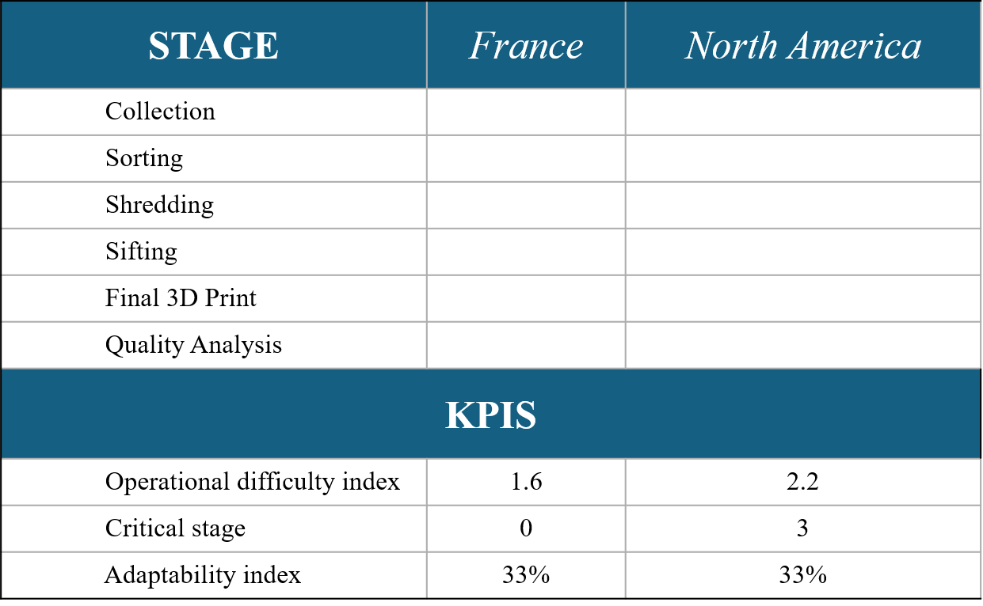
Figure 2. The range of difficulty of implementing the proposed methodology by stage in French and North American scenarios, categorized as low (green = 1), intermediate (yellow = 2), and high (red = 3).
The collection stage proved to be more challenging in Canada compared to France. In France, the collection process was coordinated directly with the university, simplifying logistics. In Canada, stricter waste collection policies on the university campus complicate the process, which is mainly driven by concerns over potential hazards. As a result, bottles had to be collected with the help of householders. Another notable difference was the collection method. Collectors were placed within university facilities in France, while a door-to-door approach was implemented to gather the materials in Canada.
In both contexts, sorting the bottle body and cap was avoided, as the objective was to 3D-print the entire bottle. However, label removal proved to be time-consuming in both cases, so it was classified as having an intermediate difficulty level. Identifying an alternative method to streamline this step is necessary to improve the efficiency of the methodology.
The shredding process presented significant challenges in the North American context, highlighting the need for specialized shredding equipment. Such equipment would ensure the efficient processing of plastic waste materials while preventing a substantial increase in temperature and minimizing the time required for this task.
The 3D printing process proved to be challenging in both contexts. Among the difficulties encountered, flow consistency emerged as a primary issue. To address this challenge, the study explored the impact of material heterogeneity on the consistent flow of the extrudate. Therefore, granulometry, flow assessment, and 3D printing quality evaluation were conducted. Four different particle types were evaluated in this step: 1) commercial pellets (virgin PLA) as a benchmark, 2) flakes directly shredded from water bottles, 3) shredder particles from previous 3D-printed parts, and 4) laboratory pellets (pelletized). To evaluate the flow inconsistency for each particle type, a 3D printing parameter known as the extrusion multiplier (EM) was employed.
Regarding the KPIs, France demonstrates a lower average operational difficulty (ODI = 1.6) compared to North America (ODI = 2.2), suggesting that the process stages are generally more accessible, requiring less technical complexity and resource investment. Moreover, France presents no critical stages (CS = 0) defined as those classified with high difficulty (red level)—whereas North America displays three critical stages (CS = 3), indicating more significant implementation barriers, particularly in the collection, shredding, and 3D printing stages. This result suggests that technological solutions are more readily applicable or established in the French context.
In terms of adaptability across the six assessed stages (collection, sorting, shredding, sifting, 3D printing, and quality assessment), two stages were classified as low difficulty (green) in both contexts, corresponding to an adaptability rate of 33%. For the full implementation and increase in the percentage of adaptability, key factors must be addressed: securing a stable material supply, where community engagement is vital; ensuring reprocessing feasibility through accessible technologies; and resolving technical challenges related to printability and material consistency.
The overall results showed that the proposed methodology for reproducing the DRAM process of post-consumer water bottles has the potential to be replicated in a different context. According to the results, the proposed methodology can be implemented within a local circuit and leverages open-source technologies that are easily adaptable. However, scoring procedure remains partially subjective. Future applications could further strengthen the robustness of the ODI, CS, and AdI by involving multiple independent evaluators and assessing inter-rater agreement.

Granulometry and flow

3.2.1 Granulometry
Previous studies reported that flakes of around 9 mm² are suitable for 3D printing with a crammer feeder (Suescun Gonzalez et al., 2024), while particles below 22 mm² can be printed without jamming or under-extrusion issues, regardless of shape (Reich et al., 2019; Woern et al., 2018). However, flow inconsistencies observed during replication in a North American context highlight the need to further examine particle granulometry and flow behavior.
The particle images and histograms show that processing method strongly affects size distribution and morphology (Fig. 3). Flakes and shredded particles presented broad distributions, with mean areas of 5.02 ± 2.4 mm² and 9.97 ± 4.19 mm², respectively. Their irregular morphology and high variability may hinder stable material flow during extrusion, increasing the risk of defects such as under/over-extrusion, inconsistent layer deposition, or incomplete parts.
By contrast, pelletized particles showed a narrower distribution, mainly between 7 and 11 mm², with a mean of 8.9 ± 1.89 mm². Commercial pellets were even more uniform, ranging mainly from 11 to 14 mm², with a mean of 12.6 ± 0.89 mm². This greater uniformity, together with the regular morphology of commercial pellets, likely improves flow through the extruder and supports more consistent material delivery (O Pozo Michelangelli et al., 2011), (Wang et al., 2024). Thus, achieving uniform size distribution and morphology remains a key challenge for recycled FGF feedstocks.

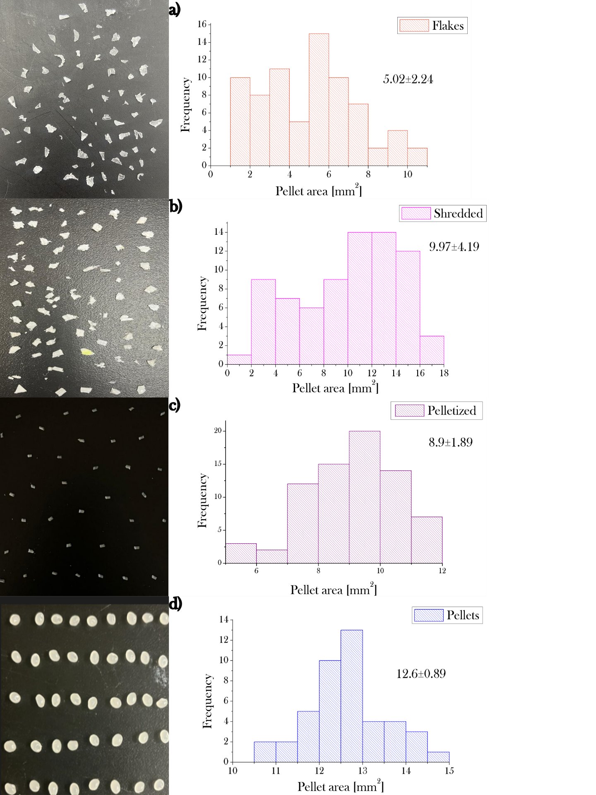
Figure 3. Particles and histograms of: (a) plastic bottles directly shredded (flakes); (b) plastics shredded from 3D printed waste parts (shredded); (c) homemade pellets from shredded plastic bottles; and (d) commercial virgin PLA pellets as a benchmark (vPellets).

Flow

Previous studies have shown that increasing the extrusion multiplier (EM) can reduce void content (Gordeev et al., 2018), improve inter-layer and inter-raster adhesion (Ariel Leong et al., 2022), and enhance the tensile properties of FFF parts (Ghorbani et al., 2022). However, its role in flow regulation with respect to pellet granulometry and particle size remains underexplored. Therefore, two geometries were used to assess flow consistency: a snake-shaped specimen to evaluate width variation with increasing EM, and a square specimen for qualitative and dimensional assessment.

Flow experiments were conducted using four particle types: commercial virgin PLA pellets as a benchmark, bottle flakes, shredded particles from previous 3D printed parts, and laboratory-made pellets. The results showed under-extrusion when irregular particles were used, confirming the need to consider EM as a key process parameter. In FGF printing, EM regulates material flow by adjusting the screw rotation speed in the conveying mechanism.

3.2.2.1 Snake-shaped geometry
The testing area of the snake-shaped geometry was conceived, taking the extrusion multiplier from 100% to 350% with increments of 50. This parameter was manually changed directly from the web control during the 3D printing process with the M221 gcode.
The relation between the percentage of EM and the line width of the four 3D printed particle types, i.e., vPellets, flakes, shredded, and pelletized, is presented in Fig. 4. The results show that the line width is augmented in all four cases. However, commercial pellets have the largest and most consistent growth when increasing the EM, showing a steady upward trend of roughly 20% with each increment. This growth might suggest that vPellets respond strongly to changes in EM for their uniformity and spherical shape, which facilitates smoother flow in the extruder (O. P. Michelangelli et al., 2011). Pelletized materials also exhibit a relatively smooth response, though to a lesser extent than vPellets. This behavior indicates a relatively controlled response to EM changes, likely due to the uniform morphology of the pelletized particles. Contrarily, some inconsistencies in the EM increase response were found when extruding shredded particles, indicating that their less uniform shape might cause more variability in the flow. Lastly, concerning the flakes, the results showed the smallest and most variable response to changes in the EM. The line width is relatively constant despite changing the EM, showing no significant variation compared to the other particle types. This result suggests that flakes exhibit lower flowability, resulting in inconsistent material extrusion from the nozzle and, consequently, minimal change in width despite an increased EM. This behavior could be due to the irregular morphology and broad size distribution of the flakes compared to pellets.

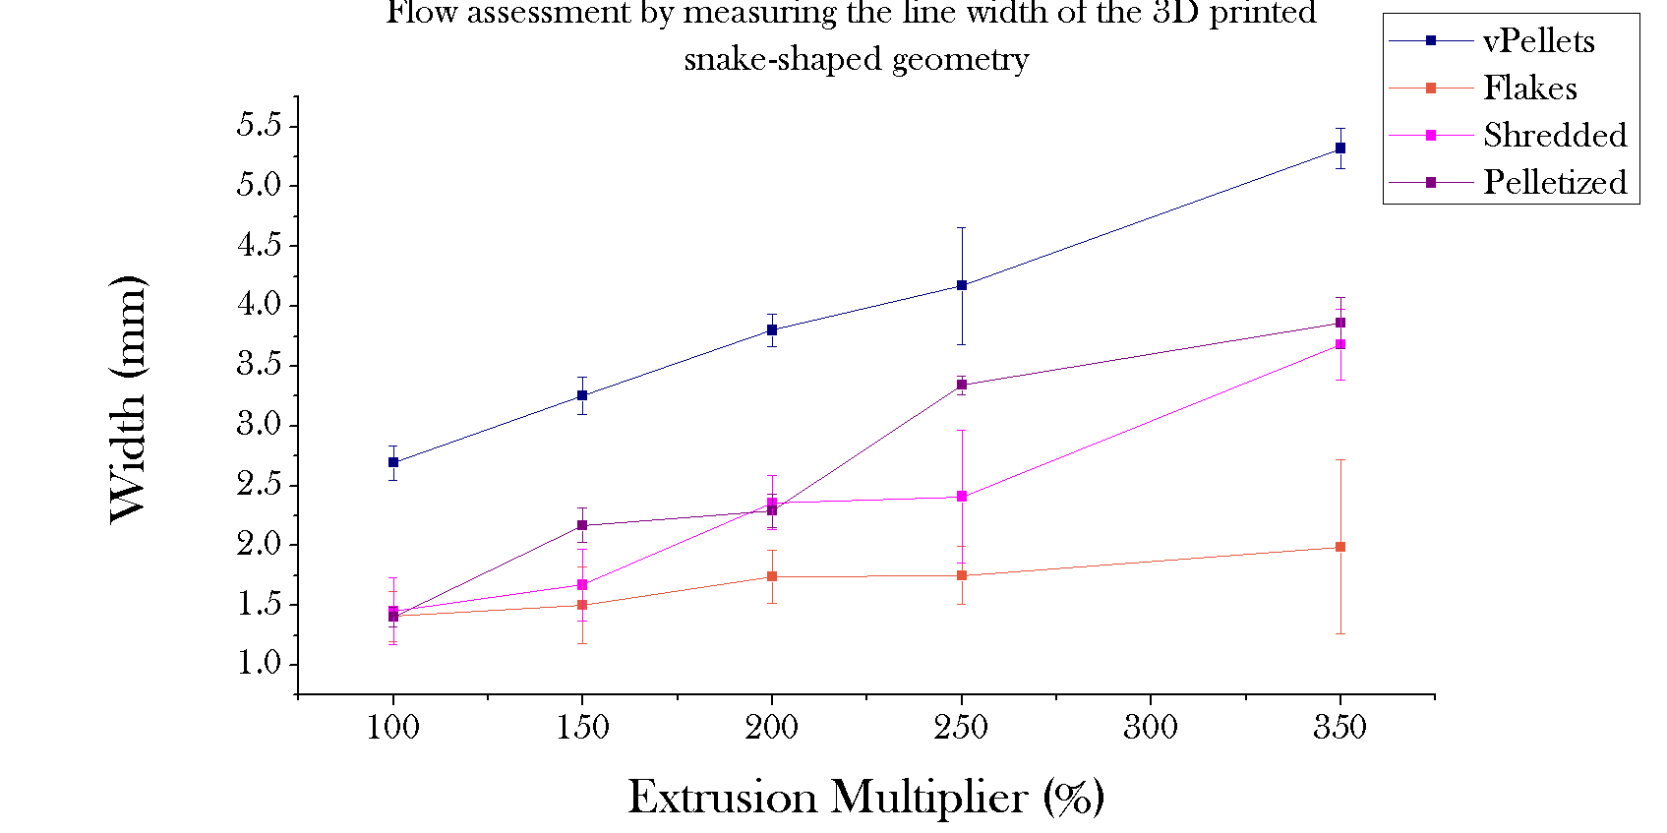
Figure 4. Flow assessment by different particle types: vPellets (commercial PLA), flakes, shredded, and pelletized (from plastic bottles).

3.2.2.2 Squares
The effect of the extrusion multiplier (EM) was qualitatively assessed using 3D printed square specimens. As shown in Fig. 5, print quality improved as EM increased from 100% to 300%, suggesting that higher EM values can partially compensate for flow limitations associated with irregular particle size and morphology.
Flakes, shredded particles, and pelletized feedstocks exhibited under-extrusion at 100% and 200% EM, whereas over-extrusion appeared at 300% EM, indicating that the optimal value likely lies between 200% and 300%. Processing shredded and pelletized materials was particularly challenging due to their brittleness, which may result from repeated thermomechanical and thermo-oxidative degradation cycles causing chain scission and branching (Pinheiro et al., 2004).The heterogeneous size and shape of these particles further contributed to inconsistent material flow and reduced print quality. Additional reprocessing through a second 3D printing cycle likely exacerbated material degradation and brittleness.
Commercial virgin PLA pellets showed more favorable behavior. At 100% EM, only minor under-extrusion was observed, while 200% and 300% EM resulted in over-extrusion, suggesting that an intermediate value (e.g., 150% EM) would provide optimal print quality.
Overall, the results demonstrate that particle granulometry and morphology strongly influence extrusion behavior and print quality. Feedstocks with heterogeneous particles require higher EM values to compensate for flow irregularities and maintain consistent material deposition. Therefore, EM should be adjusted according to feedstock characteristics to achieve stable extrusion and improved 3D printing performance.

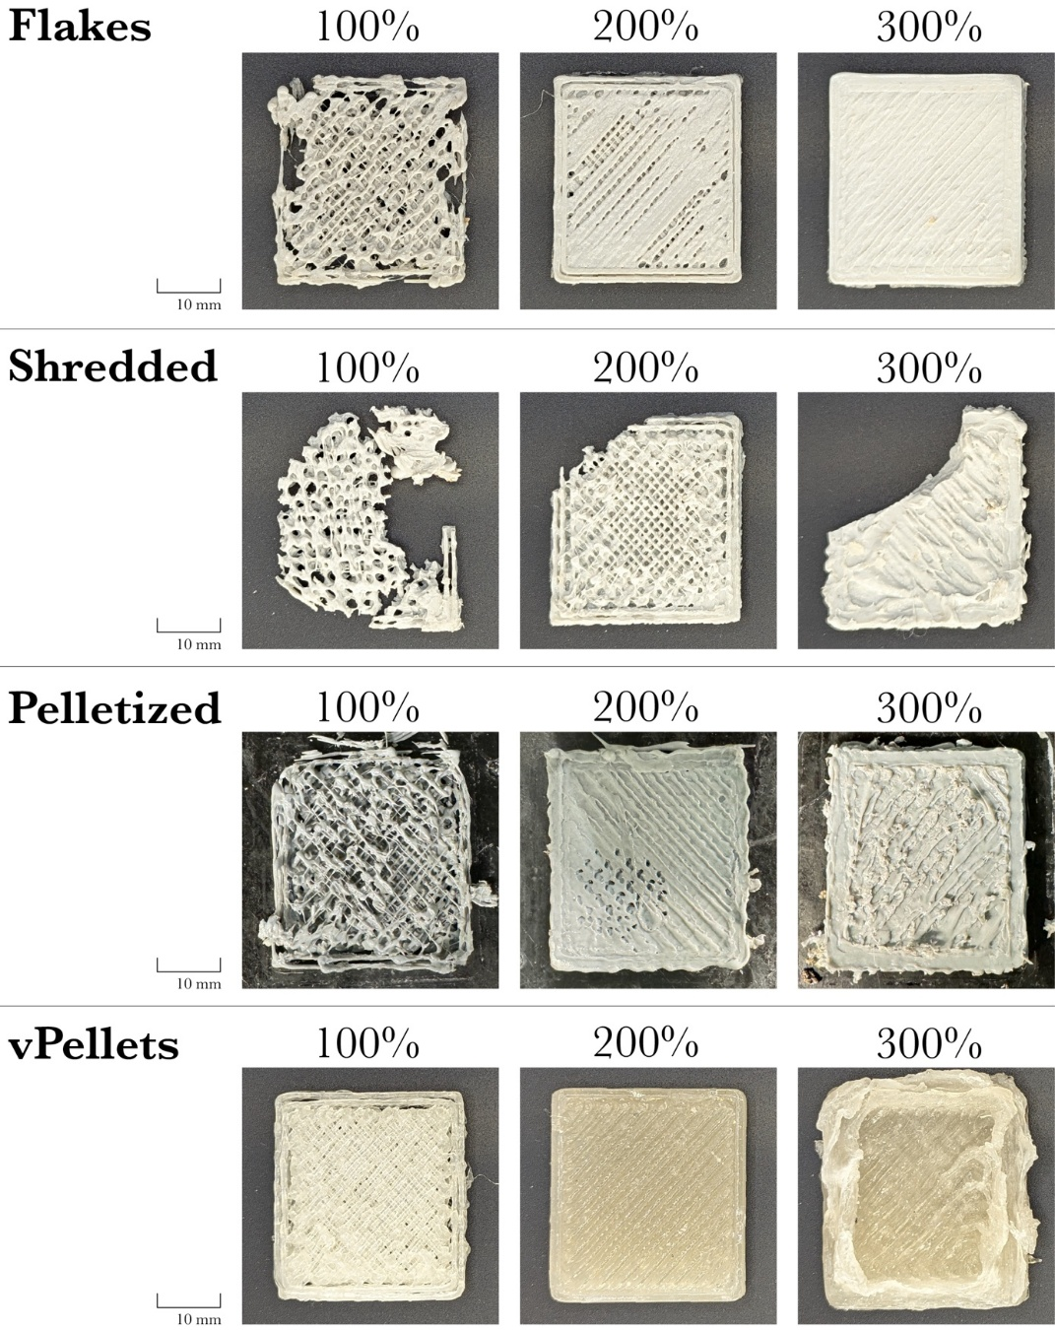
Figure 5. Visual assessment of EM influence based on the different particle types (from top to bottom): Flakes, Shredded, Pelletized (from plastic bottles), and vPellets (commercial PLA).

Application case study
A case study was 3D printed to assess the feasibility of using recycled water bottles in a real-world application. The objective was to relate particle granulometry and flowability to practical manufacturing performance. A decorative crown molding was selected because it requires large material volumes while facing limited mechanical demands, allowing evaluation of both functional and aesthetic applications.
The part was printed using commercial virgin PLA pellets (benchmark), recycled bottle flakes, and pelletized feedstock (Fig. 6). Commercial pellets produced the best results, yielding a smooth and homogeneous surface with good layer adhesion and no visible warping or delamination (Fig. 6a). In contrast, parts printed from recycled flakes exhibited rougher surfaces, irregular layers, and visible delamination (Fig. 6b). Similar to the tensile specimens (Appendix C) and the previous 3D printed samples, using shredded material resulted in brittle structures, while the pelletized recycled feedstock showed poor bed adhesion, delamination, and brittleness, preventing successful fabrication of a complete object. Consequently, the printed object obtained with this material was not included in the figure.
These defects are likely associated with material degradation during recycling and subsequent thermal processing, which can reduce molecular weight and mechanical performance (Inoya et al., 2012). In addition, the compatibilizer may not have sufficiently improved interfacial bonding (Chu et al., 2022; Yesu et al., 2024), resulting in weak layer adhesion and delamination (Gao et al., 2021; Yin et al., 2018). Another challenge associated with 3D printing arises from the crystallization behavior of polymers. During cooling, crystallization can induce volumetric contraction and dimensional changes in the deposited material. In the absence of a temperature-controlled printing chamber, the large thermal gradient between the extruded material and the surrounding environment can promote non-uniform shrinkage, leading to warping and distortion of the final printed geometry(Chatham et al., 2019). Irregular extrusion flow and bubble formation further suggest pressure fluctuations and feedstock heterogeneity. Warping was partially mitigated through the use of a nano-polymer adhesive (Lent, n.d.), increased bed temperature, and reduced initial layer height (Table 1).
The results highlight the importance of achieving uniform particle size and morphology to ensure stable extrusion and high-quality FGF printing. While commercial pellets provided superior performance, recycled flakes and pelletized materials demonstrated potential for practical applications. Further improvements in recycling, pelletizing, and material compatibilization are needed to enhance print quality. Finally, a comprehensive life cycle assessment will be required to evaluate the environmental and economic feasibility of distributed recycling and additive manufacturing (DRAM) in specific geographical contexts.
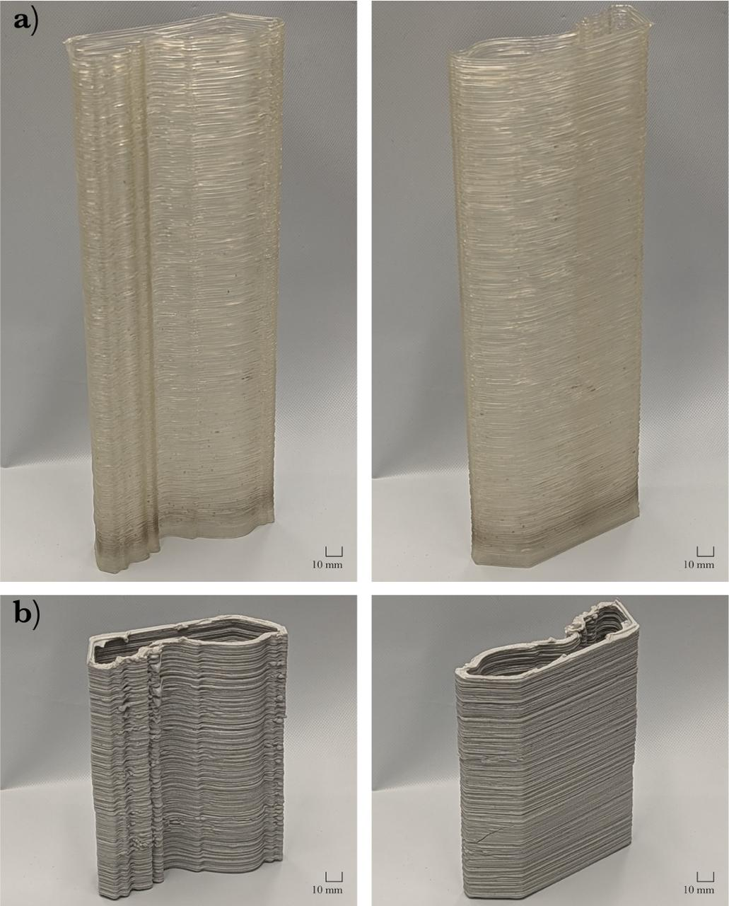
Figure 6. Application case study from the decorative sector (crown molding for interior wall decoration) 3D printed with (a) commercial virgin PLA pellets and (b) recycled water bottle flakes.

4 Conclusions and future work
This study assessed the potential replicability of the recycling process for post-consumer plastic waste, specifically PET and HDPE from water bottles, through large-scale FGF 3D printing within a North American context. By employing the DRAM model, the research provides insights into the reproducibility of the process, highlighting the main challenges encountered in changing the geographical context. This work also demonstrates the impact of different particle shapes on the flow consistency and 3D printing quality, which are crucial for the global implementation of this model in different geographical contexts.
The reproducibility of the model was assessed based on a suggested methodology developed considering a first geographical context as a benchmark, i.e., the French context. Although the model is indeed reproducible, the findings highlight some considerations to be addressed for full replicability of this DRAM model:
- Material sourcing: Establishing a bank is important for obtaining enough material for the recycling process. Short-circuit collection proved to be feasible, although engaging the community is essential for scaling up the collection process.
- Material transformation: The ease of reprocessing the collected material depends largely on the available technologies, whether in marketplaces, fab labs, or research facilities. To this end, Open-source technologies can be used to reduce associated costs and foster scaling up.
- Printability challenges: While using recycled 3D printing feedstock is feasible, certain technical issues still need to be resolved to optimize the extrudate consistency and the quality of the 3D printed objects.
The challenges encountered during the 3D printing stage led to an assessment of the material flowability by comparing different particle shapes usually processed with FGF 3D printing, such as flakes, shredded particles, and pellets. Tuning the EM parameter was proposed as a potential solution to mitigate these issues in real-world contexts.
The results demonstrated how variations in material granulometry impact the behavior of the 3D print bead width, depending on the EM. Commercial virgin pellets exhibit more consistent flow and superior 3D printing quality, while recycled flakes lead to inconsistent extrudate and more 3D printing defects due to irregular granulometry of the particles and broad size distribution. Specifically, pellets display the most uniform distribution and a significant increase in bead width as the EM increases, suggesting better flowability. In contrast, flakes showed less variability in the line width when modifying the EM, implying reduced precision during the extrusion process. Under the investigated condition, visual improvements in the 3D printing quality were observed by increasing the EM, with values of around 300 % for flakes and 150 % for pellets providing suitable printing behavihour among the EM values evaluated. However, these values should not be interpreted as optimized conditions, and a systematic Design of Experiments (DoE), followed by appropriate statistical optimization, would be required to determine optimal EM values. Additionally, flow inconsistencies still occur when 3D printing complex parts, such as decorative objects, requiring flow monitoring to avoid part failures. Therefore, the integration of sensors and digital twin technologies to monitor real-time data about the flow could facilitate the use of flakes without requiring pelletization, avoiding additional heating cycles that could potentially degrade the material and decrease its properties.
Despite some limitations in the recycled feedstock, including under-extrusion and mechanical brittleness of the 3D-printed parts, the findings show the feasibility of utilizing recycled plastics in 3D printing for functional applications. The proposed approach should be understood as a local and distributed strategy for the transformation of post-consumer plastic waste rather than as an alternative to centralized industrial recycling systems. Therefore, future research should focus on refining the material preparation process, optimizing extrusion parameters, and improving the mixing of compatibilizers to achieve better 3D printing quality, allowing the fabrication of more complex geometries. A comprehensive life cycle assessment is also essential to evaluate the environmental and economic benefits of implementing this methodology in different geographical contexts. Overall, this study contributes to the ongoing efforts to integrate sustainable practices in manufacturing by providing a pathway for local recycling plastic waste through large-scale open-source 3D printing technologies in scalable contexts.
Declaration of competing interests
The authors declare that they have no known competing financial interests or personal relationships that could have appeared to influence the work reported in this paper.
Acknowledgements
The authors would like to thank the LUE program for the financing of the thesis, the Lorraine Fab Living Lab platform. This work was supported by the Natural Sciences and Engineering Research Council of Canada and the Thompson Endowment. This paper is an extension of a conference paper called “Evaluation of the potential of large-scale 3D printing to promote a circular economy of PET plastic bottles: comparison between European and North American”, published as open access in the Springer book series Lecture Notes in Mechanical Engineering “Safe and Sustainable value creation by design” presented at the Global Conference on Sustainable Manufacturing 2025 (GCSM 2025) in Bologna, Italy.
CRediT authorship contribution statement
Catalina Suescun Gonzalez: Conceptualization, Methodology, Software, Formal analysis, Investigation, Data curation, Writing –original draft preparation, Visualization.
Aditi Basdeo: Formal analysis, Investigation, Software, Data curation, Writing – review & editing.
Alessia Romani: Formal analysis, Investigation, Software, Writing – review & editing, Visualization.
Fabio Cruz: Validation, Writing – review & editing.
Cécile Nouvel, Hakim Boudaoud, Supervision, Validation, Writing – review & editing, Funding acquisition.
Joshua Pearce: Conceptualization, Supervision, Validation, Methodology, Writing – review & editing, Funding acquisition.
Data Availability Statement:
The CAD models, STL files, and 3D printing profiles are available in the OSF repository available at https://doi.org/10.17605/OSF.IO/W9XQN. Other data supporting the findings of this study are available from the authors upon request.

References

Academy - Precious Plastic Community [WWW Document], n.d. URL https://community.preciousplastic.com (accessed 9.23.24).
Adekunle, A.S., Adeleke, A.A., Sam Obu, C.V., Ikubanni, P.P., Ibitoye, S.E., Azeez, T.M., 2020. Recycling of plastics with compatibilizer as raw materials for the production of automobile bumper. Cogent Engineering 7, 1801247. https://doi.org/10.1080/23311916.2020.1801247
Ahangar, P., Cooke, M.E., Weber, M.H., Rosenzweig, D.H., 2019. Current Biomedical Applications of 3D Printing and Additive Manufacturing. Applied Sciences 9, 1713. https://doi.org/10.3390/app9081713
Alexandre, A., Cruz Sanchez, F.A., Boudaoud, H., Camargo, M., Pearce, J.M., 2020. Mechanical Properties of Direct Waste Printing of Polylactic Acid with Universal Pellets Extruder: Comparison to Fused Filament Fabrication on Open-Source Desktop Three-Dimensional Printers. 3D Printing and Additive Manufacturing 7, 237–247. https://doi.org/10.1089/3dp.2019.0195
Antonopoulos, I., Faraca, G., Tonini, D., 2021. Recycling of post-consumer plastic packaging waste in the EU: Recovery rates, material flows, and barriers. Waste Management 126, 694–705. https://doi.org/10.1016/j.wasman.2021.04.002
Ariel Leong, J.J., Koay, S.C., Chan, M.Y., Choo, H.L., Tshai, K.Y., Ong, T.K., 2022. Composite Filament Made from Post-used Styrofoam and Corn Husk Fiber for Fuse Deposition Modeling. Journal of Natural Fibers 19, 7033–7048. https://doi.org/10.1080/15440478.2021.1941488
Askari, M., Hutchins, D.A., Thomas, P.J., Astolfi, L., Watson, R.L., Abdi, M., Ricci, M., Laureti, S., Nie, L., Freear, S., Wildman, R., Tuck, C., Clarke, M., Woods, E., Clare, A.T., 2020. Additive manufacturing of metamaterials: A review. Additive Manufacturing 36, 101562. https://doi.org/10.1016/j.addma.2020.101562
ASTM International, 2021. ISO/ASTM 52900-21 Standard Terminology for Additive Manufacturing – General Principles – Terminology. ASTM International, West Conshohocken, PA.
Babilotte, J., Martin, B., Guduric, V., Bareille, R., Agniel, R., Roques, S., Héroguez, V., Dussauze, M., Gaudon, M., Le Nihouannen, D., Catros, S., 2021. Development and characterization of a PLGA-HA composite material to fabricate 3D-printed scaffolds for bone tissue engineering. Materials Science and Engineering: C 118, 111334. https://doi.org/10.1016/j.msec.2020.111334
Balwada, J., Samaiya, S., Mishra, R.P., 2021. Packaging Plastic Waste Management for a Circular Economy and Identifying a better Waste Collection System using Analytical Hierarchy Process (AHP). Procedia CIRP, The 28th CIRP Conference on Life Cycle Engineering, March 10 – 12, 2021, Jaipur, India 98, 270–275. https://doi.org/10.1016/j.procir.2021.01.102
Barlow, J.W., Paul, D.R., 1984. Mechanical compatibilization of immiscible blends. Polymer Engineering & Science 24, 525–534. https://doi.org/10.1002/pen.760240804
Bilal, E., Glazer, Y.R., Sassaman, D.M., Seepersad, C.C., Webber, M.E., 2024. Circularity: Understanding the Environmental Tradeoffs of Additive Manufacturing with Waste Plastics. Recycling 9, 72. https://doi.org/10.3390/recycling9050072
Bos, F., Wolfs ,Rob, Ahmed ,Zeeshan, and Salet, T., 2016. Additive manufacturing of concrete in construction: potentials and challenges of 3D concrete printing. Virtual and Physical Prototyping 11, 209–225. https://doi.org/10.1080/17452759.2016.1209867
Braanker, G.B., n.d. [PDF] Developing a plastics recycling add-on for the RepRap 3D printer. G.B. Braanker, J.E.P. Duwel, J.J. Flohil & G.E. Tokaya - Free Download PDF [WWW Document]. URL https://silo.tips/download/developing-a-plastics-recycling-add-on-for-the-reprap-3d-printer-gb-braanker-jep (accessed 2.24.23).
Caceres-Mendoza, C., Santander-Tapia, P., Cruz Sanchez, F.A., Troussier, N., Camargo, M., Boudaoud, H., 2023. Life cycle assessment of filament production in distributed plastic recycling via additive manufacturing. Cleaner Waste Systems 5, 100100. https://doi.org/10.1016/j.clwas.2023.100100
Catania, V., Ventura, D., 2014. An approch for monitoring and smart planning of urban solid waste management using smart-M3 platform. Proceedings of 15th Conference of Open Innovations Association FRUCT 24–31. https://doi.org/10.1109/FRUCT.2014.6872422
Chatham, C.A., Zawaski, C.E., Bobbitt, D.C., Moore, R.B., Long, T.E., Williams, C.B., 2019. Semi-Crystalline Polymer Blends for Material Extrusion Additive Manufacturing Printability: A Case Study with Poly(ethylene terephthalate) and Polypropylene. Macromolecular Materials and Engineering 304, 1800764. https://doi.org/10.1002/mame.201800764
Chu, J.S., Koay, S.C., Chan, M.Y., Choo, H.L., Ong, T.K., 2022. Recycled plastic filament made from post-consumer expanded polystyrene and polypropylene for fused filament fabrication. Polymer Engineering & Science 62, 3786–3795. https://doi.org/10.1002/pen.26144
Create 3D Print Filament - Filament Maker and Plastic Shredder | 3devo [WWW Document], n.d. URL https://www.3devo.com (accessed 9.23.24).
Cruz Sanchez, F.A., Boudaoud, H., Hoppe, S., Camargo, M., 2017. Polymer recycling in an open-source additive manufacturing context: Mechanical issues. Additive Manufacturing 17, 87–105. https://doi.org/10.1016/j.addma.2017.05.013
Curmi, A., Rochman, A., 2022. From Theory to Practice: Development and Calibration of Micro Pellet Extruder for Additive Manufacturing. KEM 926, 34–45. https://doi.org/10.4028/p-b22a9a
Das, S., Bourell, D.L., Babu, S.S., 2016. Metallic materials for 3D printing. MRS Bulletin 41, 729–741. https://doi.org/10.1557/mrs.2016.217
Dobrovszky, K., Ronkay, F., n.d. Effects of SEBS-g-MA on rheology, morphology and mechanical properties of PET/HDPE blends. https://doi.org/DOI:%2010.3139/217.2970
Duty, C., Ajinjeru, C., Kishore, V., Compton, B., Hmeidat, N., Chen, X., Liu, P., Hassen, A.A., Lindahl, J., Kunc, V., 2018. What makes a material printable? A viscoelastic model for extrusion-based 3D printing of polymers. Journal of Manufacturing Processes 35, 526–537. https://doi.org/10.1016/j.jmapro.2018.08.008
Ennaceur, A., Elouedi, Z., Lefevre, E., 2013. Multicriteria Decision Making Based on Qualitative Assessments and Relational Belief, in: Congress of the Italian Association for Artificial Intelligence, AI*IA’2013, Lecture Notes in Computer Science. Springer International Publishing, Turin, Italy, pp. 48–59. https://doi.org/10.1007/978-3-319-03524-6_5
Esposito Corcione, C., Gervaso, F., Scalera, F., Padmanabhan, S.K., Madaghiele, M., Montagna, F., Sannino, A., Licciulli, A., Maffezzoli, A., 2019. Highly loaded hydroxyapatite microsphere/ PLA porous scaffolds obtained by fused deposition modelling. Ceramics International 45, 2803–2810. https://doi.org/10.1016/j.ceramint.2018.07.297
eXpert 7600 Single Column Universal Testing Machine, n.d. . ADMET. URL https://www.admet.com/products/universal-testing-machines/expert-7600/ (accessed 4.14.25).
Fidan, I., Huseynov, O., Ali, M.A., Alkunte, S., Rajeshirke, M., Gupta, A., Hasanov, S., Tantawi, K., Yasa, E., Yilmaz, O., Loy, J., Popov, V., Sharma, A., 2023. Recent Inventions in Additive Manufacturing: Holistic Review. Inventions 8, 103. https://doi.org/10.3390/inventions8040103
Gao, X., Qi, S., Kuang, X., Su, Y., Li, J., Wang, D., 2021. Fused filament fabrication of polymer materials: A review of interlayer bond. Additive Manufacturing 37, 101658. https://doi.org/10.1016/j.addma.2020.101658
Garwacki, M., Cudnik, I., Dziadowiec, D., Szymczak, P., Andrzejewski, J., 2024. The Development of Sustainable Polyethylene Terephthalate Glycol-Based (PETG) Blends for Additive Manufacturing Processing—The Use of Multilayered Foil Waste as the Blend Component. Materials 17, 1083. https://doi.org/10.3390/ma17051083
Ghorbani, J., Koirala, P., Shen, Y.-L., Tehrani, M., 2022. Eliminating voids and reducing mechanical anisotropy in fused filament fabrication parts by adjusting the filament extrusion rate. Journal of Manufacturing Processes 80, 651–658. https://doi.org/10.1016/j.jmapro.2022.06.026
Giani, N., Mazzocchetti, L., Benelli, T., Picchioni, F., Giorgini, L., 2022. Towards sustainability in 3D printing of thermoplastic composites: Evaluation of recycled carbon fibers as reinforcing agent for FDM filament production and 3D printing. Composites Part A: Applied Science and Manufacturing 159, 107002. https://doi.org/10.1016/j.compositesa.2022.107002
Gonzalez, C., Basdeo, A., Romani, A., Pearce, J., 2024. Assessing Reproducibility of Large-scale 3D printing of using Recycled PET Plastic Bottles in a North American Context.
Gonzalez, C.S., Basdeo, A., Romani, A., Cruz Sanchez, F.A., Nouvel, C., Boudaoud, H., Pearce, J.M., 2026. Evaluation of the Potential of Large-Scale 3D Printing to Promote a Circular Economy of PET Plastic Bottles: Comparison Between European and North American, in: Kohl, H., Seliger, G., Dietrich, F., Campana, G. (Eds.), Safe and Sustainable Value Creation by Design. Springer Nature Switzerland, Cham, pp. 524–533. https://doi.org/10.1007/978-3-032-21157-6_58
Gordeev, E.G., Galushko, A.S., Ananikov, V.P., 2018. Improvement of quality of 3D printed objects by elimination of microscopic structural defects in fused deposition modeling. PLOS ONE 13, e0198370. https://doi.org/10.1371/journal.pone.0198370
Goyanes, A., 2015. 3D Printing of Medicines: Engineering Novel Oral Devices with Unique Design and Drug Release Characteristics. Mol. Pharmaceutics 12, 4077–4084. https://doi.org/10.1021/acs.molpharmaceut.5b00510
Goyanes, A., Buanz, A.B.M., Basit, A.W., Gaisford, S., 2014. Fused-filament 3D printing (3DP) for fabrication of tablets. International Journal of Pharmaceutics 476, 88–92. https://doi.org/10.1016/j.ijpharm.2014.09.044
Halidi, S.N.A.M., Abdullah, J., 2012. Moisture effects on the ABS used for Fused Deposition Modeling rapid prototyping machine. 2012 IEEE Symposium on Humanities, Science and Engineering Research 839–843. https://doi.org/10.1109/SHUSER.2012.6268999
Image J, n.d. Imaje j [WWW Document]. URL https://imagej.net/ij/download.html (accessed 9.18.24).
Iñiguez, C.G., Michel, E., González-Romero, V.M., González-Nuñez, R., 2000. Morphological stability of postconsumer PET/HDPE blends. Polymer Bulletin 45, 295–302. https://doi.org/10.1007/s002890070034
Inoya, H., Wei Leong, Y., Klinklai, W., Thumsorn, S., Makata, Y., Hamada, H., 2012. Compatibilization of recycled poly(ethylene terephthalate) and polypropylene blends: Effect of polypropylene molecular weight on homogeneity and compatibility. Journal of Applied Polymer Science 124, 3947–3955. https://doi.org/10.1002/app.34405
Ismail, H., H., Nasir, M., 2002. The effect of various compatibilizers on mechanical properties of polystyrene/polypropylene blend. Polymer Testing 21, 163–170. https://doi.org/10.1016/S0142-9418(01)00064-2
ISO 527-1:2019 [WWW Document], n.d. . ISO. URL https://www.iso.org/standard/75824.html (accessed 4.5.25).
Jemghili, R., Taleb, A.A., Khalifa, M., 2021. A bibliometric indicators analysis of additive manufacturing research trends from 2010 to 2020. Rapid Prototyping Journal 27, 1432–1454. https://doi.org/10.1108/RPJ-11-2020-0274
Justino Netto, J.M., Idogava, H.T., Frezzatto Santos, L.E., Silveira, Z. de C., Romio, P., Alves, J.L., 2021. Screw-assisted 3D printing with granulated materials: a systematic review. Int J Adv Manuf Technol 115, 2711–2727. https://doi.org/10.1007/s00170-021-07365-z
Kassab, A., Al Nabhani, D., Mohanty, P., Pannier, C., Ayoub, G.Y., 2023. Advancing Plastic Recycling: Challenges and Opportunities in the Integration of 3D Printing and Distributed Recycling for a Circular Economy. Polymers 15, 3881. https://doi.org/10.3390/polym15193881
Kerdlap, P., Purnama, A.R., Low, J.S.C., Tan, D.Z.L., Barlow, C.Y., Ramakrishna, S., 2022. Comparing the environmental performance of distributed versus centralized plastic recycling systems: Applying hybrid simulation modeling to life cycle assessment. Journal of Industrial Ecology 26, 252–271. https://doi.org/10.1111/jiec.13151
Kreiger, M.A., Mulder, M.L., Glover, A.G., Pearce, J.M., 2014. Life cycle analysis of distributed recycling of post-consumer high density polyethylene for 3-D printing filament. Journal of Cleaner Production 70, 90–96. https://doi.org/10.1016/j.jclepro.2014.02.009
Lent, R., n.d. Nano Polymer Adhesive [WWW Document]. Vision Miner. URL https://visionminer.com/products/nano-polymer-adhesive (accessed 9.25.24).
Little, H.A., Tanikella, N.G., J. Reich, M., Fiedler, M.J., Snabes, S.L., Pearce, J.M., 2020. Towards Distributed Recycling with Additive Manufacturing of PET Flake Feedstocks. Materials 13, 4273. https://doi.org/10.3390/ma13194273
Michelangelli, O Pozo, Yamanoi, M., Gaspar-Cunha, A., Covas, J.A., 2011. Flow Dynamics and Structure of solid pellets along the channel of a single screw extruder.
Michelangelli, O. P., Yamanoi, M., Gaspar-Cunha, A., Covas, J.A., 2011. Modelling pellet flow in single extrusion with DEM. https://doi.org/10.1177/0954408911418159
Mohd Pu’ad, N.A.S., Abdul Haq, R.H., Mohd Noh, H., Abdullah, H.Z., Idris, M.I., Lee, T.C., 2020. Review on the fabrication of fused deposition modelling (FDM) composite filament for biomedical applications. Materials Today: Proceedings, 4th Advanced Materials Conference 2018, 4th AMC 2018, 27th & 28th November 2018, Hilton Kuching Hotel, Kuching, Sarawak, Malaysia 29, 228–232. https://doi.org/10.1016/j.matpr.2020.05.535
Mohseni, M., Hutmacher, D.W., Castro, N.J., 2018. Independent Evaluation of Medical-Grade Bioresorbable Filaments for Fused Deposition Modelling/Fused Filament Fabrication of Tissue Engineered Constructs. Polymers 10, 40. https://doi.org/10.3390/polym10010040
Mwanza, B.G., Mbohwa, C., 2017. Drivers to Sustainable Plastic Solid Waste Recycling: A Review. Procedia Manufacturing, 14th Global Conference on Sustainable Manufacturing, GCSM 3-5 October 2016, Stellenbosch, South Africa 8, 649–656. https://doi.org/10.1016/j.promfg.2017.02.083
Navarro, R., Parres, F., Crespo, J.E., Sánchez-Caballero, S., Sellés, M.A., 2020. COMPATIBILIZATION OF POSTCONSUMER PET/HDPE BLENDS. 2.
Nguyen, P.Q.K., Panta, J., Famakinwa, T., Yang, R. (Chunhui), Ahmed, A., Stapleton, M., Sassaman, D., Snabes, S., Craff, C., 2024. Influences of printing parameters on mechanical properties of recycled PET and PETG using fused granular fabrication technique. Polymer Testing 132, 108390. https://doi.org/10.1016/j.polymertesting.2024.108390
Oberloier, S., Whisman, N.G., Pearce, J.M., 2022. Finding Ideal Parameters for Recycled Material Fused Particle Fabrication-Based 3D Printing Using an Open Source Software Implementation of Particle Swarm Optimization. 3D Printing and Additive Manufacturing. https://doi.org/10.1089/3dp.2022.0012
Okunola, O.I., Oyebade, D.A., Olanrewaju, O.O., 2019. DEVELOPMENT OF SHREDDING AND WASHING MACHINE FOR POLYETHYLENE TEREPHTHALATE (PET) BOTTLES PELLETIZER.
Ovens | VWR [WWW Document], n.d. URL https://us.vwr.com/store/category/ovens/592755 (accessed 9.25.24).
Park, J.B., An, S.H., Jung, J.W., Lee, J.U., 2023. Three-Dimensional Printing of Recycled Polypropylene and Activated Carbon Coatings for Harmful Gas Adsorption and Antibacterial Properties. Polymers 15, 1173. https://doi.org/10.3390/polym15051173
Pavlo, S., Fabio, C., Hakim, B., Mauricio, C., 2018. 3D-Printing Based Distributed Plastic Recycling: A Conceptual Model for Closed-Loop Supply Chain Design, in: 2018 IEEE International Conference on Engineering, Technology and Innovation (ICE/ITMC). Presented at the 2018 IEEE International Conference on Engineering, Technology and Innovation (ICE/ITMC), pp. 1–8. https://doi.org/10.1109/ICE.2018.8436296
Pinheiro, L.A., Chinelatto, M.A., Canevarolo, S.V., 2004. The role of chain scission and chain branching in high density polyethylene during thermo-mechanical degradation. Polymer Degradation and Stability 86, 445–453. https://doi.org/10.1016/j.polymdegradstab.2004.05.016
Plastic odyssey, n.d. La plateforme des technologies open source du recyclage | Plastic Odyssey [WWW Document]. Plastic Odyssey - Technology. URL https://technology.plasticodyssey.org/ (accessed 9.23.24).
Progress in 3D Printing of Carbon Materials for Energy‐Related Applications - Fu - 2017 - Advanced Materials - Wiley Online Library [WWW Document], n.d. URL https://advanced.onlinelibrary.wiley.com/doi/10.1002/adma.201603486 (accessed 4.5.25).
Prusa 3D, n.d. Imprimantes 3D Original Prusa par Joseph Prusa directement [WWW Document]. Prusa3D by Josef Prusa. URL https://www.prusa3d.com/fr/ (accessed 9.18.24).
Ravindran, A., Scsavnicki, S., Nelson, W., Gorecki, P., Franz, J., Oberloier, S., Meyer, T.K., Barnard, A.R., Pearce, J.M., 2019. Open Source Waste Plastic Granulator. Technologies 7, 74. https://doi.org/10.3390/technologies7040074
Razavi, S., Shojaei, A., Bagheri, R., 2011. Binary and ternary blends of high-density polyethylene with poly(ethylene terephthalate) and polystyrene based on recycled materials. Polymers for Advanced Technologies 22, 690–702. https://doi.org/10.1002/pat.1567
Reclaimer [WWW Document], n.d. . Filabot. URL https://www.filabot.com/products/filabot-reclaimer-1 (accessed 9.23.24).
Reich, M.J., Woern, A.L., Tanikella, N.G., Pearce, J.M., 2019. Mechanical Properties and Applications of Recycled Polycarbonate Particle Material Extrusion-Based Additive Manufacturing. Materials 12, 1642. https://doi.org/10.3390/ma12101642
Rezaei, J., 2016. Best-worst multi-criteria decision-making method: Some properties and a linear model. Omega 64, 126–130. https://doi.org/10.1016/j.omega.2015.12.001
Romani, A., Levi, M., 2024. Large-Format Material Extrusion Additive Manufacturing for Circular Economy Practices: A Focus on Product Applications with Materials from Recycled Plastics and Biomass Waste. Sustainability 16, 7966. https://doi.org/10.3390/su16187966
Romani, A., Levi, M., Pearce, J.M., 2023. Recycled polycarbonate and polycarbonate/acrylonitrile butadiene styrene feedstocks for circular economy product applications with fused granular fabrication-based additive manufacturing. Sustainable Materials and Technologies 38, e00730. https://doi.org/10.1016/j.susmat.2023.e00730
Romani, A., Paramatti, M., Gallo, L., Levi, M., 2024a. Large-format material extrusion additive manufacturing of PLA, LDPE, and HDPE compound feedstock with spent coffee grounds. Int J Adv Manuf Technol 134, 1845–1861. https://doi.org/10.1007/s00170-024-14214-2
Romani, A., Perusin, L., Ciurnelli, M., Levi, M., 2024b. Characterization of PLA feedstock after multiple recycling processes for large-format material extrusion additive manufacturing. Materials Today Sustainability 25, 100636. https://doi.org/10.1016/j.mtsust.2023.100636
Santander, P., Cruz Sanchez, F.A., Boudaoud, H., Camargo, M., 2020. Closed loop supply chain network for local and distributed plastic recycling for 3D printing: a MILP-based optimization approach. Resources, Conservation and Recycling 154, 104531. https://doi.org/10.1016/j.resconrec.2019.104531
Serris, I., Serris, P., Frey, K.M., Cho, H., 2020. Development of 3D-Printed Layered PLGA Films for Drug Delivery and Evaluation of Drug Release Behaviors. AAPS PharmSciTech 21, 256. https://doi.org/10.1208/s12249-020-01790-1
Singh, N., Singh, R., Ahuja, I.P.S., Farina, I., Fraternali, F., 2019. Metal matrix composite from recycled materials by using additive manufacturing assisted investment casting. Composite Structures 207, 129–135. https://doi.org/10.1016/j.compstruct.2018.09.072
Small, K.A., 2015. The bottleneck model: An assessment and interpretation. Economics of Transportation, Special Issue on Collective Contributions in the Honor of Richard Arnott 4, 110–117. https://doi.org/10.1016/j.ecotra.2015.01.001
Suescun Gonzalez, C., Cruz Sanchez, F.A., Boudaoud, H., Nouvel, C., Pearce, J.M., 2024. Multi-material distributed recycling via material extrusion: recycled high density polyethylene and poly (ethylene terephthalate) mixture. Polymer Engineering & Science n/a. https://doi.org/10.1002/pen.26643
Suhaimi, N.A.S., Muhamad, F., Abd Razak, N.A., Zeimaran, E., 2022. Recycling of polyethylene terephthalate wastes: A review of technologies, routes, and applications. Polymer Engineering & Science 62, 2355–2375. https://doi.org/10.1002/pen.26017
Taghavi, S.K., Shahrajabian, H., Hosseini, H.M., 2018. Detailed comparison of compatibilizers MAPE and SEBS-g-MA on the mechanical/thermal properties, and morphology in ternary blend of recycled PET/HDPE/MAPE and recycled PET/HDPE/SEBS-g-MA. Journal of Elastomers & Plastics 50, 13–35. https://doi.org/10.1177/0095244317698738
Taufik, M., Jain, P.K., 2024. Additive Manufacturing with Interdisciplinary Applications, in: Kumar, N., Singh, G., Trehan, R., Davim, J.P. (Eds.), Advances in Materials and Agile Manufacturing. Springer Nature, Singapore, pp. 183–210. https://doi.org/10.1007/978-981-99-6601-1_17
Tay, Y.W.D., Li, M.Y., Tan, M.J., 2019. Effect of printing parameters in 3D concrete printing: Printing region and support structures. Journal of Materials Processing Technology 271, 261–270. https://doi.org/10.1016/j.jmatprotec.2019.04.007
Thingiverse.com, n.d. 1:24 Scale Crown Moulding by Rjewiss [WWW Document]. Thingiverse. URL https://www.thingiverse.com/thing:2673555 (accessed 4.5.25).
Traugott, T.D., Barlow, J.W., Paul, D.R., 1983. Mechanical compatibilization of high density polyethylene–poly(ethylene terephthalate) blends. Journal of Applied Polymer Science 28, 2947–2959. https://doi.org/10.1002/app.1983.070280922
Trituradoras de mandíbula: alta calidad y fiabilidad de RETSCH [WWW Document], n.d. URL https://www.retsch.es/es/productos/molienda/trituradoras-de-mandibulas/ (accessed 9.23.24).
Truby, R.L., Lewis, J.A., 2016. Printing soft matter in three dimensions. Nature 540, 371–378. https://doi.org/10.1038/nature21003
Vaucher, J., Demongeot, A., Michaud, V., Leterrier, Y., 2022. Recycling of Bottle Grade PET: Influence of HDPE Contamination on the Microstructure and Mechanical Performance of 3D Printed Parts. Polymers 14, 5507. https://doi.org/10.3390/polym14245507
Vicente, C.M.S., Sardinha, M., Reis, L., Ribeiro, A., Leite, M., 2023. Large-format additive manufacturing of polymer extrusion-based deposition systems: review and applications. Prog Addit Manuf 8, 1257–1280. https://doi.org/10.1007/s40964-023-00397-9
Wang, C., Cui, Y., Nie, J., Hu, B., Fang, J., Cao, Z., 2024. 3D printing-aided numerical study of particle shape effect on behaviours of dry granular flows interacting with rigid barriers. Computers and Geotechnics 167, 106038. https://doi.org/10.1016/j.compgeo.2023.106038
Wittbrodt, B.T., Glover, A.G., Laureto, J., Anzalone, G.C., Oppliger, D., Irwin, J.L., Pearce, J.M., 2013. Life-cycle economic analysis of distributed manufacturing with open-source 3-D printers. Mechatronics 23, 713–726. https://doi.org/10.1016/j.mechatronics.2013.06.002
Woern, A.L., Byard, D.J., Oakley, R.B., Fiedler, M.J., Snabes, S.L., Pearce, J.M., 2018. Fused Particle Fabrication 3-D Printing: Recycled Materials’ Optimization and Mechanical Properties. Materials 11, 1413. https://doi.org/10.3390/ma11081413
Yesu, A., T., R., Goyal, S., Banerjee, S.S., 2024. Improving 3D printability and interlayer adhesion in ABS/PP immiscible polymer blends. Polymer Engineering & Science 64, 3912–3922. https://doi.org/10.1002/pen.26821
Yin, J., Lu, C., Fu, J., Huang, Y., Zheng, Y., 2018. Interfacial bonding during multi-material fused deposition modeling (FDM) process due to inter-molecular diffusion. Materials & Design 150, 104–112. https://doi.org/10.1016/j.matdes.2018.04.029
Zander, N.E., Gillan, M., Burckhard, Z., Gardea, F., 2019. Recycled polypropylene blends as novel 3D printing materials. Additive Manufacturing 25, 122–130. https://doi.org/10.1016/j.addma.2018.11.009
Zander, N.E., Gillan, M., Lambeth, R.H., 2018. Recycled polyethylene terephthalate as a new FFF feedstock material. Additive Manufacturing 21, 174–182. https://doi.org/10.1016/j.addma.2018.03.007

Appendix A - Snake-shaped and square geometries
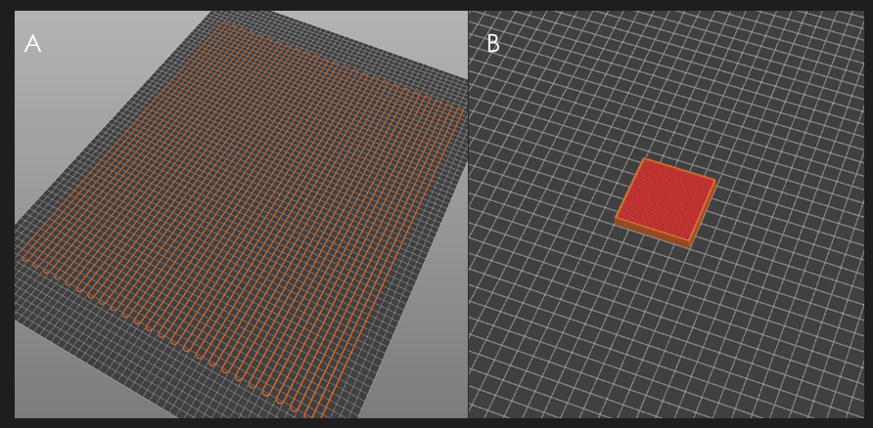
Figure A1. Gcode preview of the 3D models used for the flow consistency and EM evaluation: (a) Snake-shaped geometry, (b) Square. Size of the grid squares: 10 × 10 mm.

Table A1. Mean values ± SD of flow assessment Snake-shaped geometry by different particle types.
EM % | PLA | Flakes | Shredded | Pelletized
100 | 2.69 ± 0.14 | 1.41 ± 0.21 | 1.45 ± 0.28 | 1.405 ± 0.08
150 | 3.25 ± 0.16 | 1.5 ± 0.32 | 1.67 ± 0.30 | 2.17 ± 0.14
200 | 3.8 ± 0.14 | 1.74 ± 0.22 | 2.36 ± 0.23 | 2.29 ± 0.14
250 | 4.17 ± 0.49 | 1.75 ± 0.24 | 2.41 ± 0.56 | 3.34 ± 0.07
350 | 5.32 ± 0.17 | 1.99 ± 0.73 | 3.68 ± 0.29 | 3.86 ± 0.21

Appendix B - Waste collection
From the five worldwide techniques, Balwada et al. (2021)(Balwada et al., 2021), proved that the deposit/refund method was appropriate following social, environmental, cost, and sorting impacts, although this method is designed for more centralized recycling. In this model, companies can give some kind of extrinsic retribution, e.g., credits or money, in exchange for the waste, similar to the buy-back center method. According to Catania et al. (2014) (Catania and Ventura, 2014), there are two modalities for solid waste collection in urban areas: door-to-door collection, which requires regular service and higher operational costs, and indirect collection using containers or communal bins placed in strategic locations, offering a cost-effective approach.

Table B1. Waste collection techniques according to (Balwada et al., 2021; Catania and Ventura, 2014).
Collection Method | Description | Advantages | Disadvantages
Vehicular Collection Method (VC) | Plastic waste is collected daily from houses by vehicles. Ideal for densely populated areas. | Reduces odors by collecting waste immediately. | High operational costs due to daily frequency.
Vehicular Collection Method (VC) |  | Increases efficiency in large urban areas. | Requires a large number of vehicles and personnel.
Curbside Collection Method (CC) | Bins are placed in specific locations within a locality and emptied once a day. | Reduces operational costs. | May cause odors and accumulation if not emptied regularly
Curbside Collection Method (CC) |  | Convenient for households to drop waste at a nearby point. | Less practical for dispersed rural areas.
Drop Off Recycling (DOC) | Large, dedicated bins or machines for sorting plastics by type, placed near communities for easy access. | Facilitates source segregation. | Less convenient for users who need to travel to the bins.
Drop Off Recycling (DOC) |  | Encourages community participation. | Requires regular maintenance.
Buy Back Centre (BBC) | Fixed or mobile centers where citizens exchange waste for useful products or cash. | Incentivizes recycling with direct rewards. | Requires logistical and financial systems.
Buy Back Centre (BBC) |  | Can adapt to urban and rural areas. | Participation depends on the rewards offered.
Deposit/Refund Method (D/R) | "Bank-like" stations where plastic is deposited in exchange for credit, cash, or tax benefits. | Promotes reuse through financial incentives. | High initial cost to establish infrastructure.
Deposit/Refund Method (D/R) |  | Reduces litter in public spaces. | Requires public education on how the system works.

Appendix C- Compatibilization and Tensile test
Since the materials derived from the bottles (flakes) consist of a blend of two different polymer types, i.e., PET and HDPE, compatibilizers based on SEBS were incorporated to enhance their compatibility. Specifically, SEBS G1652 and SEBS C1010 were added to the flakes at concentrations of 5% and 10% w/w to determine the optimal compatibilizer ratio. The ternary blends were directly processed through FGF 3D printing to evaluate their effectiveness.
After completing the EM assessment, specimens for tensile testing were 3D printed (Table 1), incorporating compatibilizers at 5% and 10% (w/w) concentrations to improve mechanical properties. Tensile properties were evaluated in accordance with the ISO 527-1:2019 standard for Type 1B dumb-bell specimens (150 × 20 × 4 mm with a gauge length of 40 mm) (“ISO 527-1,” n.d.) using an eXpert 7600 Single Column Universal Testing Machine (ADMET, MA, US) (“eXpert 7600 Single Column Universal Testing Machine,” n.d.), fitted with a 5kN load cell. Measurements were conducted on five separate specimens for each formulation, employing a loading speed of 10 mm/min. The mean values and standard errors of tensile strength were derived from the stress-strain curves generated from the analysis.
Based on the results of the granulometry and flow tests, the flakes were 3D printed using the optimal EM (300 %) from the flow assessment for tensile testing. The tensile tests of shredded materials were not pursued due to the excessive brittle behavior observed in the square-shaped and snake-shaped samples. The primary objective was to explore the effects of different percentages of compatibilizer on the properties of the material feedstock, defining the most effective ratio. Specifically, the tests analyzed the addition of 5 % and 10 % w/t of both reactive SEBS-C1010 and non-reactive SEBS G-1652.
Non-compatibilized samples exhibit higher tensile strength compared to their compatibilized counterparts, as shown in Fig. C1. This fact is attributed to the rubber-like nature of the compatibilizers, which typically decreases tensile strength while increasing the elongation at break(Dobrovszky and Ronkay, n.d.; Garwacki et al., 2024; Navarro et al., 2020; Traugott et al., 1983). Specimens compatibilized with 5 wt% G-1652 showed an increase in tensile strength (19MPa), representing approximately an 11% and 18 % increase, compared with those containing 10 wt% G-1652 (17 MPa) and 5-10 wt% C1010 (~16 MPa), respectively. However, specimens with 10 wt% of G-1652 showed less variability in the results, hence better repeatability. The addition of 5 wt% and 10 wt% of the reactive compatibilizer C-1010 did not significantly affect the mechanical properties of the material, reaching a value of ~16 MPa. Nevertheless, adding 5 wt% led to less variability in the experimental values. Incorporating 5 wt% compatibilizer yields slightly higher tensile strength values than incorporating 10 wt%, which aligns with trends commonly reported in the literature (Adekunle et al., 2020; Barlow and Paul, 1984; Navarro et al., 2020; Taghavi et al., 2018). Overall, the materials showed a brittle fracture behavior with immediate rupture upon testing. This result can be attributed to degradation during the recycling process or the air gaps in the diamond-shaped areas common in the 3D printing process (Wittbrodt et al., 2013). The elastomeric properties of the compatibilizer were not observed, although they were expected to enhance the elongation at break according to prior studies (Iñiguez et al., 2000; Ismail and Nasir, 2002). This result is due to inefficiencies in the material mixing during sample preparation. Consequently, the compatibilization via a single-screw machine with low residence time may be insufficient for achieving optimal mixing in both contexts, requiring additional characterization to corroborate this hypothesis.

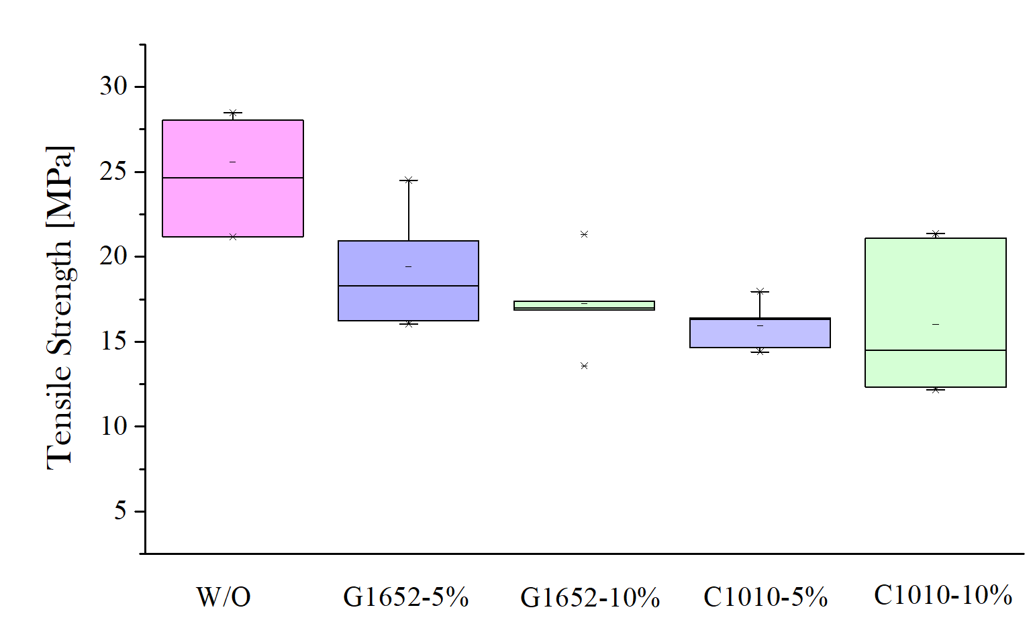
Figure C1. Tensile strength of 3D printed recycled PET/HDPE blends from plastic bottles changing the percentage of compatibilizer.

